# Assignment No:9

Practical Exercise: Chatbot Application for Customer Support using Program AB (Java AIML)

## 1) Problem Statement

Create a chatbot application for an e-commerce customer support system using Program AB (Java AIML). The chatbot should be able to answer customer queries related to product details, order status, returns, shipping information, and more.

## 2) Libraries Used

Java:  
1. **Program AB**: A Java-based implementation of AIML for creating intelligent chatbots.  
2. **AIML (Artificial Intelligence Markup Language)**: XML-based language for defining conversation patterns and responses.  
3. **Maven** (for dependency management): To include Program AB and related libraries in the project.

## 3) Theory

Chatbots are computer programs that simulate conversation with human users using natural language processing (NLP). AIML (Artificial Intelligence Markup Language) is a language for creating chatbot patterns and responses.  
  
Program AB is a Java-based chatbot engine that interprets AIML files and handles input/output for conversation. It processes the user's input and matches it to patterns defined in AIML files, providing the appropriate response based on the chatbot's knowledge base.

## 4) Methods

1. **Creating AIML Files**: Define conversation patterns in AIML, including questions about order status, returns, and product details. Each AIML file will contain `<category>`, `<pattern>`, and `<template>` tags to define input patterns and the chatbot's responses.  
2. **Setting Up Program AB**:   
 - Download and set up Program AB from its repository.  
 - Create an AIML directory and place the AIML files there.  
3. **Loading AIML Files in Java**: Use Program AB’s Java API to load the AIML files and start the chatbot engine.  
4. **Handling User Input**: The chatbot reads user input, searches for matching patterns in the AIML files, and returns the response defined in the matching category.

## 5) Advantages and Disadvantages

- **Advantages**:  
 - Easy to set up using AIML, which provides predefined templates and structure.  
 - Program AB is open-source, allowing for customization.  
 - AIML files are human-readable and easy to update without complex programming.  
   
- **Disadvantages**:  
 - Limited to pre-defined patterns, lacking true conversational AI features like contextual understanding.  
 - Requires a large set of AIML rules to cover diverse conversation topics.  
 - Hard to scale for more complex, dynamic conversations.

## 6) Diagram

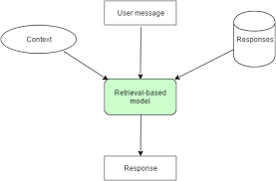

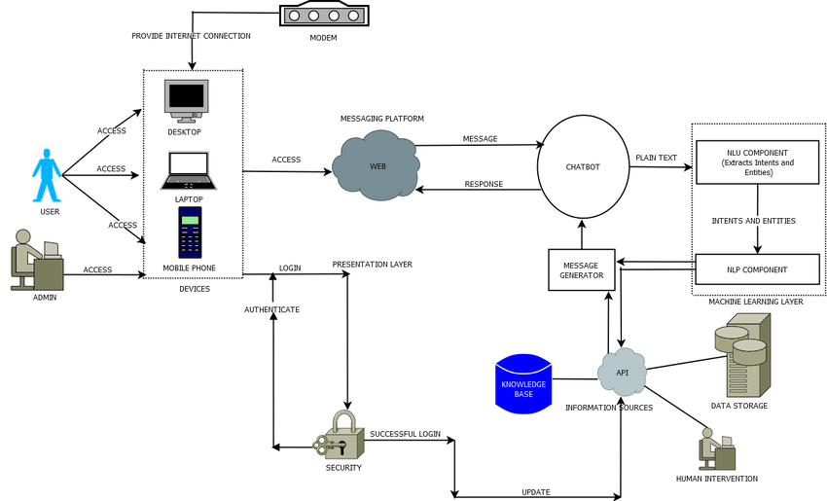

## 7) Conclusion

Program AB combined with AIML provides a powerful, rule-based solution for building chatbots, particularly for use cases like customer support, where conversations are well-defined. While it may not offer the complexity of modern AI-driven conversational bots, it is an effective solution for simple, pattern-based chatbots.